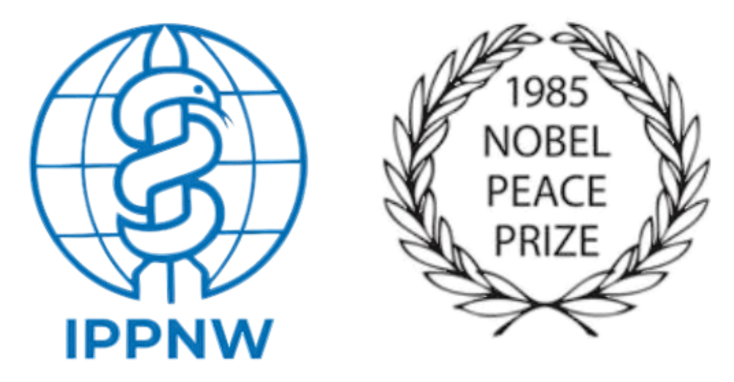

International Physicians for the Prevention of Nuclear War (IPPNW) Recommendations to the 2026 Review Conference of the Parties to the Treaty on the Non-Proliferation of Nuclear Weapons (NPT)

21 February 2026

Introduction:

We are closer to nuclear war than even at the height of the Cold War. This January, the Bulletin of the Atomic Scientists set the Doomsday Clock to 85 seconds to midnight. NPT Member States – especially the Depository Governments and other nuclear weapons states parties to the Treaty – must take affirmative action at the 2026 Review Conference to turn back the Clock.

Since the 2022 NPT Review Conference:
- Five of the nine nuclear-armed states have engaged in deadly, destabilizing armed conflict;
- The last remaining arms control treaty between the US and Russia, New START expired, leaving no binding limits or structured arms control dialogue between the two largest nuclear -armed states - or indeed any of them;
- All nine nuclear-armed states have modernized and/or expanded their nuclear arsenals, investing an estimated $100 billion in 2025 alone. For the P-5, this trajectory runs counter to their Article VI obligation to in good faith pursue disarmament, and to the obligation to pursue in good faith and to bring to a conclusion negotiations leading to nuclear disarmament, which the International Court of Justice has determined applies to all states;
- The 2015 and 2022 Review Conferences to the NPT failed to adopt a consensus outcome document. The 2023, 2024, and 2025 NPT Preparatory Committees failed to adopt consensus final recommendations for the 2026 Review Conference;
- Nuclear power plants in Ukraine have been subject to unprecedented, extensive and ongoing attacks and disruption during Russia's invasion, and nuclear facilities in Iran, an NPT Member State, have been attacked by nuclear-armed Israel and the USA, causing great and unacceptable risks of a radiological disaster; and
- The majority of UN Member States became signatories or States Parties to the Treaty on the Prohibition of Nuclear Weapons (TPNW).

Threat multipliers, including the real possibility of unregulated technologies like artificial intelligence (AI) integrating into nuclear weapons command and control systems, cyberwarfare and the climate crisis, increase the risk of nuclear war. Urgent action is needed to reverse course.

Humanitarian Impacts of Nuclear Weapons:

Nuclear weapons pose the most acute existential threat to humanity and the environment. Unlike conventional weapons or other weapons of mass destruction, nuclear weapons can instantaneously destroy entire populations, level cities, devastate ecosystems, and cause global climate disruption and famine. They generate radioactive contamination that causes lifelong health consequences and intergenerational harm. There can be no meaningful medical or humanitarian response following their use.

Following a single nuclear detonation:

- Anyone in the immediate vicinity of the blast will be instantly vaporized;
- Those who survive the immediate detonation will suffer third degree burns on exposed skin; crush injuries, including ruptured organs [particularly lungs], fractured skulls, and compound fractures; sudden deafness due to ruptured eardrums; and temporary blindness from the initial flash;
- Mass fires would spread rapidly across urban areas, creating firestorms that consume oxygen and infrastructure alike. Hospitals, clinics, and emergency response systems would be destroyed or rendered inoperable. Healthcare workers would be killed or severely injured alongside the general population. Survivors would face catastrophic injuries without access to care;
- Exposure to ionizing radiation will lead to acute radiation sickness, which can be fatal within hours, days, or weeks due to bone marrow destruction, leading to extreme susceptibility to infection and uncontrolled internal bleeding; impaired healing; irreparable gastrointestinal damage and dehydration; and central nervous system dysfunction; and
- Those who survive the immediate radiation exposure remain at risk of multiple types of cancer (leukemia, multiple myeloma, thyroid, stomach, colon, lung, breast cancer, among others), cardiovascular disease, cataracts, birth defects, infertility and subfertility, hemorrhaging, infections, and more.

A single nuclear weapon can destroy a city and kill or severely injure the majority of its population. A nuclear war involving less than 3% of the world’s nuclear arsenals would result in:

- Upwards of 100 million direct fatalities;
- Average global temperature dropping about 1.3 degrees Celsius due to millions of tons of soot and debris blocking the sun and damaging the ozone layer;
- Global crop failure, leading to famine for a third of the world’s population; and
- Particularly high impacts over the high latitudes in the Northern Hemisphere, in nations such as Canada, Finland, Norway, Sweden, and Russia.

A full-scale nuclear war between the United States and Russia would drop temperatures across the globe an average of 10 degrees Celsius and trigger a global famine that could kill over 5 billion people worldwide within two years.

In light of the catastrophic humanitarian impacts of nuclear weapons, IPPNW calls on States Party to the NPT to:
- Reaffirm the 2010 NPT outcome expressing, “deep concern at the continued risk for humanity represented by the possibility that these weapons could be used and the catastrophic humanitarian consequences that would result from the use of nuclear weapons,” and use the humanitarian impacts of nuclear weapons (HINW) as the basis for all future deliberations;
- Affirm that both horizontal and vertical proliferation increase the likelihood of nuclear war and jeopardize the future integrity of the NPT. States Parties must reject the transfer, hosting, “sharing” and continued stockpiling and increased investment in nuclear weapons;
- Place a permanent firewall between AI and related technologies and nuclear weapons command and control systems, ensuring that humans maintain full control over the use of nuclear weapons;
- Acknowledge the value of and engage constructively with the Treaty on the Prohibition of Nuclear Weapons (TPNW), which entered into force in 2021, and affirm its complementarity to the NPT. The TPNW provides the legal and diplomatic framework for progressing Article VI of the NPT and to achieve the total elimination of nuclear weapons. The TPNW contains the only comprehensive prohibition of nuclear weapons and the only framework for the elimination of nuclear weapons enshrined in an international treaty. All NPT States Parties should participate meaningfully and in good faith in the upcoming TPNW Review Conference (30 November - 4 December, UN Headquarters in New York) and join the Treaty at the earliest possible date;
- Establish concrete and timebound disarmament actions for the P-5, consistent with their Article VI obligations. Urgent action, beginning with an agreement by the US and Russian governments to abide by the limits of the expired New START Treaty, is necessary to reduce the immediate risk of nuclear war and to ensure that the NPT remains a credible and durable instrument to prevent nuclear war;
- Confirm that decisions taken by NPT Review Conferences remain binding for States Parties beyond the next review cycle, unless superseded or subsequently revoked; and
- Establish a binding instrument to prevent attacks on nuclear facilities resulting in risk of radiological releases, particularly nuclear reactors, spent reactor fuel pools, high level radioactive waste storages, and reprocessing plants.

